Write a c programming to find the area of rectangle using printf
Algorithm:
Step1:start
Step2:read the value of b
Step3:read the value of h
Step4:area=base*height
Step5:print a=b*h
Step6:end
Flowchart:
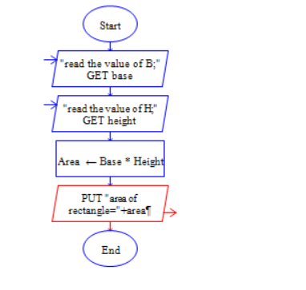
Program:
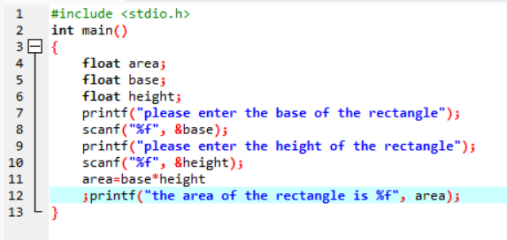
Output:
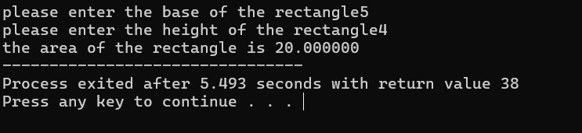
Area of the rectangle is a=base*height

